|  |  |
| --- | --- |
| Ex No:04 | **ARRAY LIST** |
| Date:16-08-19 |

**AIM:**

To develop a java console application to perform string operations.

**REQUIREMENTS:**

Write functions for the following

a. Append - add at end

b. Insert – add at particular index

c. Search

d. List all string starts with given letter

**ALGORITHM:**

**Step1:** Declare a package String Collections.

**Step2**: Create the string array class and put the operation for array list.

**Step3**: Create a separate operation for append

**Step4**: Ask the user to get the option for processing the operation.

**Step5**: Display the result.

**CLASS DIAGRAM:**

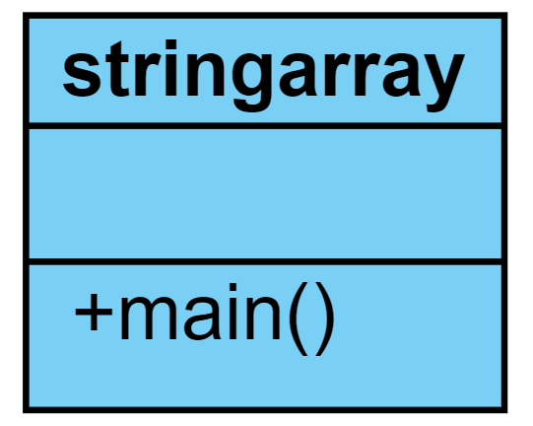

**PROGRAM:**

/*******

* created by Akhshy Ganesh

* Gmail: akhshyganeshb@gmail.com

* program to find string

*/

**package** stringcollections;

**import** java.util.ArrayList;

**import** java.util.Scanner;

**public** **class** stringarray {

**public** **static** **void** main(String[] args) {

**int** option;

**int** index,i;

String n;

Scanner sc=**new** Scanner(System.***in***);

ArrayList<String> str;

str=**new** ArrayList<String>();

**while**(**true**)

{

System.***out***.println("1. To add an String number at the end");

System.***out***.println("2. To insert an string number at particular index");

System.***out***.println("3. To search for a string");

System.***out***.println("4. To display all the string");

System.***out***.println("5. Exit");

System.***out***.print("Enter your choice:");

option=sc.nextInt();

**switch**(option)

{

**case** 1:

System.***out***.print("Enter a String:");

n=sc.next();

str.add(n);

System.***out***.println("The given String is added at the end");

**break**;

**case** 2:

System.***out***.print("Enter a String:");

n=sc.next();

System.***out***.print("Enter the index:");

index=sc.nextInt();

str.add(index,n);

System.***out***.println("The given String is added at the given index");

**break**;

**case** 3:

System.***out***.print("Enter a String:");

n=sc.next();

index=str.indexOf(n);

**if**(index<0)

{

System.***out***.println("The given String is not available in the list");

}**else**

{

System.***out***.printf("The String %s is found at the index %d\n" ,str,index);

}

**break**;

**case** 4:

**char** l;

System.***out***.println("Enter the starting letter: ");

l=sc.next().charAt(0);

**for**(i=0;i<str.size();i++)

{

String str1 = str.get(i);

**if**(l==str1.charAt(0))

System.***out***.println(str1);

}

**break**;

**case** 5:

System.***out***.println("Thankyou for using String list application !!!");

**break**;

**default**:

System.***out***.println("Please enter a valid String !!!");

}

**if**(option==5)

{

**break**;

}

}

}

}

**OUTPUT:**

1. To add an String number at the end

2. To insert an string number at particular index

3. To search for a string

4. To find the string starting with

5. Exit

Enter your choice:1

Enter a String:akhshy

The given String is added at the end

1. To add an String number at the end

2. To insert an string number at particular index

3. To search for a string

4. To find the string starting with

5. Exit

Enter your choice:1

Enter a String:faizul

The given String is added at the end

1. To add an String number at the end

2. To insert an string number at particular index

3. To search for a string

4. To find the string starting with

5. Exit

Enter your choice:1

Enter a String:karan

The given String is added at the end

1. To add an String number at the end

2. To insert an string number at particular index

3. To search for a string

4. To find the string starting with

5. Exit

Enter your choice:2

Enter a String:bairavan

Enter the index:1

The given String is added at the given index

1. To add an String number at the end

2. To insert an string number at particular index

3. To search for a string

4. To find the string starting with

5. Exit

Enter your choice:3

Enter a String:b

The given String is not available in the list

1. To add an String number at the end

2. To insert an string number at particular index

3. To search for a string

4. To find the string starting with

5. Exit

Enter your choice:4

Enter the starting letter:

b

bairavan

1. To add an String number at the end

2. To insert an string number at particular index

3. To search for a string

4. To find the string starting with

5. Exit

Enter your choice:5

Thankyou for using String list application !!!

**RESULT:**

Thus the java Program is created to find the string in array is executed and the output is verified.